EXPT NO:8 | FORECASTING AND PREDICTIVE ANALYTICS USING TABLEAU  AND POWER BI
DATE: 14.08.2026

PRE-LAB QUESTIONS (PROVIDE BRIEF ANSWERS TO THE FOLLOWING QUESTIONS)
1. What is forecasting in the context of Business Intelligence (BI)?
Forecasting is the process of predicting future business outcomes using historical data and statistical methods. It helps organizations make better decisions about sales, demand, inventory, and resources.

2. Explain the difference between predictive analytics and descriptive analytics.
Descriptive analytics explains what happened in the past using historical data.
Predictive analytics predicts what is likely to happen in the future using statistical models and patterns.

3. Name two common forecasting methods used in Tableau and Power BI.
Time-series forecasting
Exponential smoothing

4. Why is data granularity important for accurate forecasting?
Data granularity determines the level of detail in the data, such as daily, weekly, or monthly. The right level of granularity helps identify trends and patterns accurately, leading to better forecasts.

5. Name two challenges in forecasting using multiple data sources.
- Data inconsistency – Different sources may have different formats, values, or definitions.
- Data integration issues – Combining data from multiple sources can cause missing, duplicate, or mismatched records.

IN-LAB EXERCISE:
OBJECTIVE:
To perform time series forecasting and predictive analytics on historical sales data using Tableau and Power BI, and visualize future trends for informed decision-making. PROCEDURE:
- Data Collection:
  - Import historical sales data from multiple sources:
    - Dataset 1: Sales Data (CSV) → Order ID, Order Date, Region, Sales Amount
    - Dataset 2: Promotions Data (Excel) → Promotion ID, Region, Promotion Start Date, Promotion End Date, Discount
- Data Preparation and Transformation:
  - Clean data: standardize date formats, remove duplicates, handle missing values.
  - Aggregate sales data at the required granularity (daily, weekly, or monthly).
  - Ensure numeric fields (Sales, Discount) are correct.
- Data Integration and Modeling:
  - Tableau: Connect datasets and relate them using the Region field.
  - Power BI: Create relationships in the Model view; define cardinality where necessary.
- Forecasting and Predictive Analytics:
  - Tableau:
    - Use the Forecast feature on Sales over time. o Apply trend models like Exponential Smoothing and visualize prediction intervals.

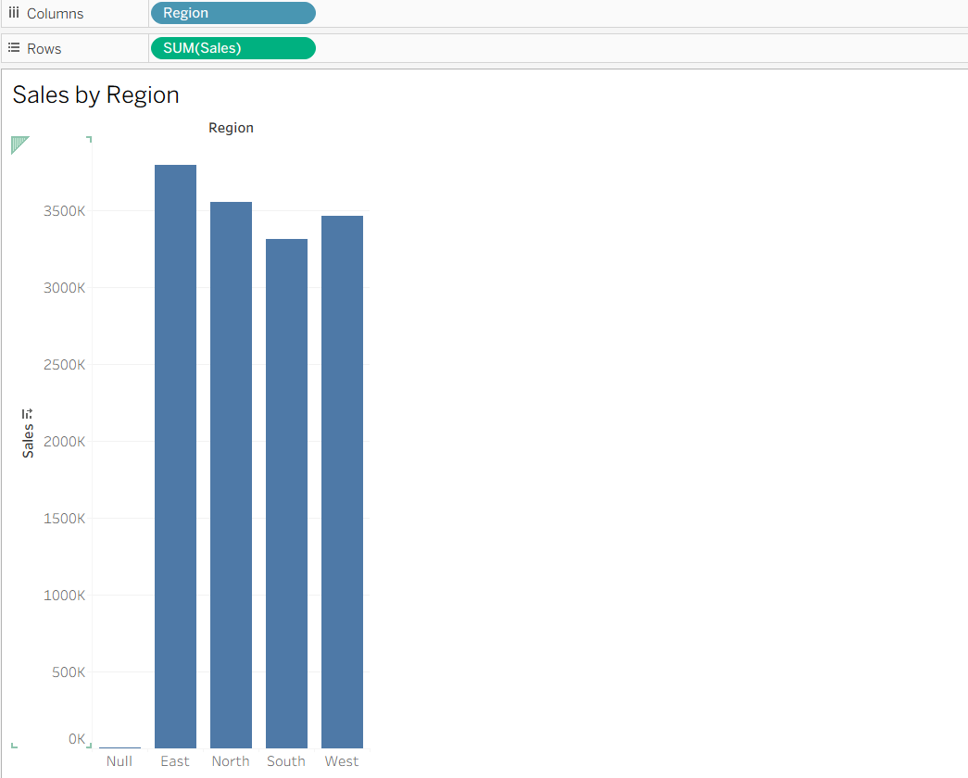

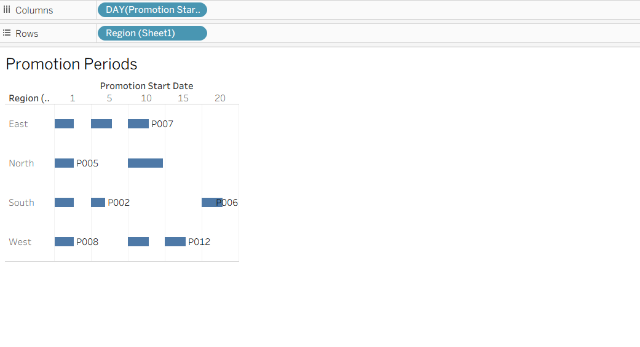
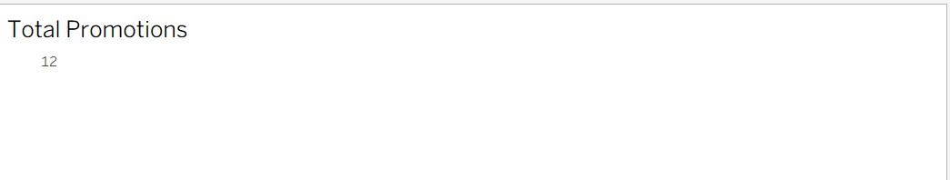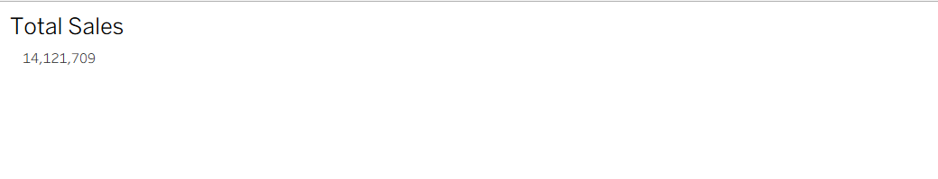
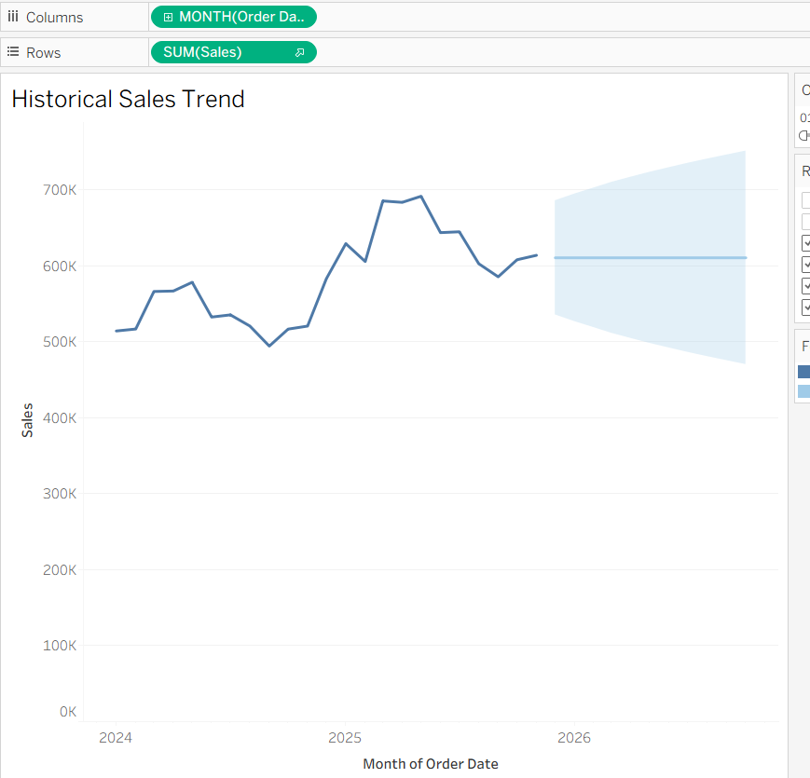
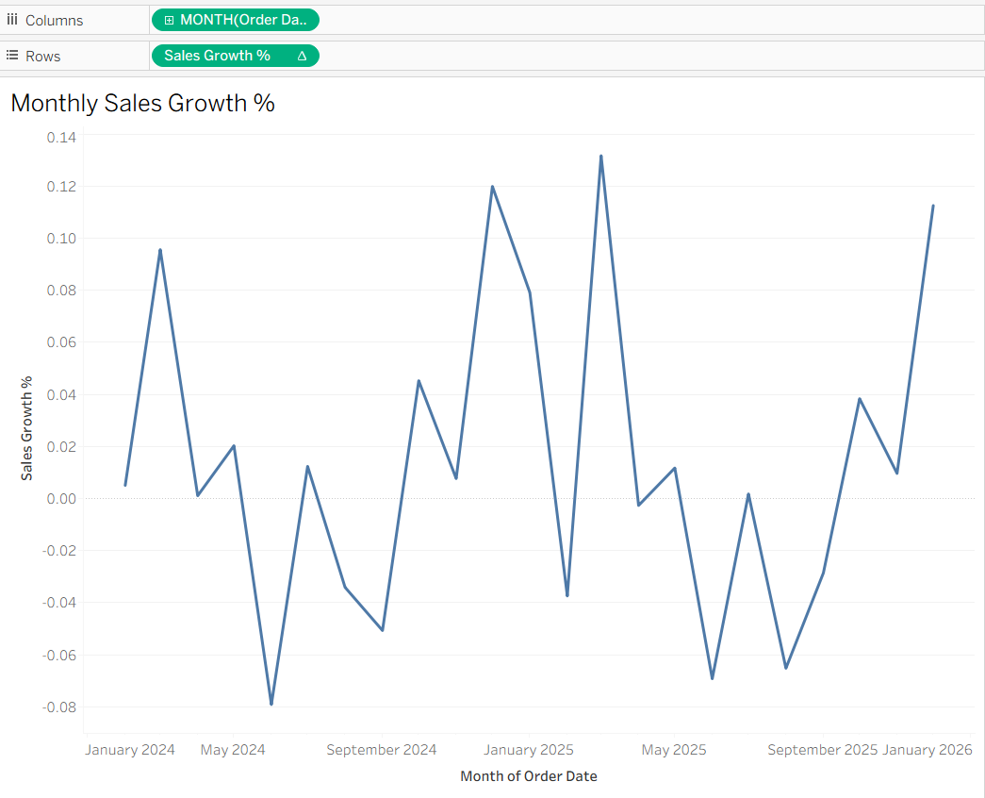
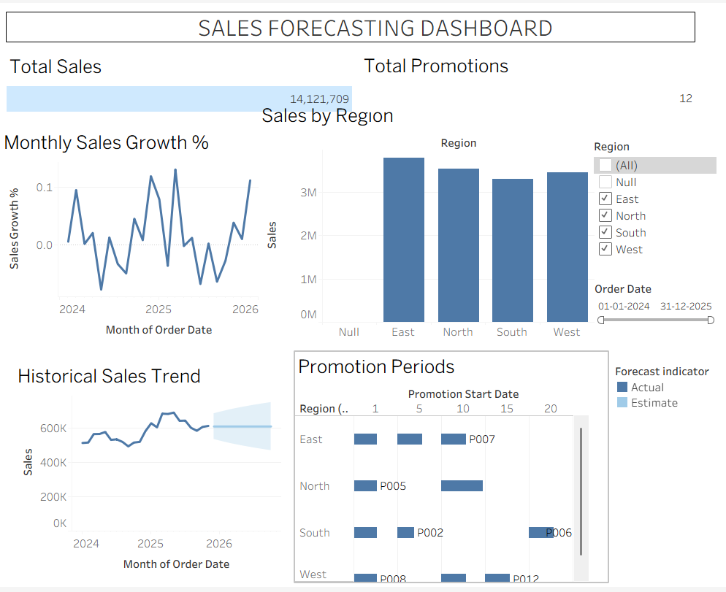

  - Power BI:
    - Use built-in forecasting in line charts. o Optionally, create a DAX measure for predicted sales using moving averages or linear regression.

b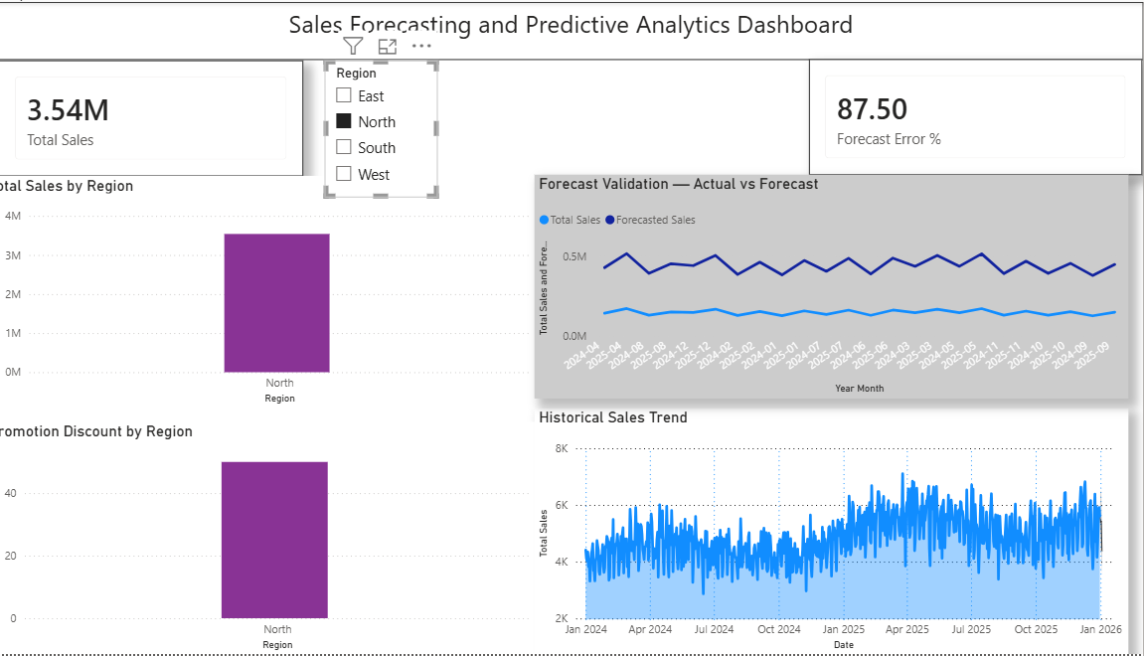
- Create Calculated Fields:
  - Forecasted Sales = Predicted value from the model
  - Sales Growth % = ((Forecasted Sales – Actual Sales) / Actual Sales) * 100
- Design a Comprehensive Dashboard:
  - Line chart showing actual vs. forecasted sales over time.
  - KPI cards: Total Forecasted Sales, Expected Growth %.
  - Use combo charts to show sales trends along with promotion periods.
  - Highlight regions with expected growth above or below target thresholds.
- Validate Forecast Accuracy:
  - Compare forecasts against actual historical sales (back-testing).
  - Adjust forecasting parameters if necessary (e.g., seasonality length, smoothing factor).
- Publishing and Sharing:
  - Tableau: Publish workbook to Tableau Public or Tableau Server.
  - Power BI: Publish report to Power BI Service and share with stakeholders.
Experiment Datasets:
  - Dataset 1: Historical Sales Data (CSV) → Order ID, Order Date, Region, Sales
  - Dataset 2: Promotions Data (Excel) → Promotion ID, Region, Promotion Start/End Date, Discount

POST-LAB QUESTIONS (PROVIDE BRIEF ANSWERS TO THE FOLLOWING QUESTIONS)
1. How did forecasting help in predicting future sales trends for business planning?
Forecasting helped predict future sales based on historical sales patterns and trends. This allows businesses to plan inventory, staffing, budgets, and marketing activities more effectively.
2. What forecasting method did you use, and why was it suitable for the dataset?
I used time-series forecasting with exponential smoothing. It was suitable because the dataset contained sales data over time, allowing the model to identify trends and predict future sales.
3. What challenges, if any, did you face regarding missing data or irregular time intervals?
The main challenges were missing values and inconsistent time intervals. These issues can affect the accuracy of the forecast, so the data needs to be cleaned and organized before forecasting.
4. How can predictive analytics influence decision-making in a retail environment?
Predictive analytics helps retailers predict customer demand, manage inventory, set prices, and plan promotions. This reduces overstocking and stock shortages while improving sales and customer satisfaction.
5. What additional data could be integrated to improve forecast accuracy?
Additional data such as competitor pricing, customer demand, promotions, seasonal trends, holidays, weather conditions, and economic indicators can be integrated to improve forecast accuracy.

RESULT:
The historical sales and promotions datasets were successfully cleaned, integrated, and modeled in Tableau and Power BI. Forecasting techniques provided predicted sales trends, growth percentages, and region-wise performance expectations. The resulting dashboards allowed managers to visualize actual vs. forecasted sales, enabling better planning and datadriven decision-making.

ASSESSMENT

Description |  | Max Marks | Marks Awarded
Pre Lab Exercise |  | 5
In Lab Exercise |  | 10
Post Lab Exercise |  | 5
Viva |  | 10
 | Total | 30
 | Faculty Signature

